Task 03 Report: Network Security Monitoring and Analysis
Prepared by: Arman Kumar
Date: March 10, 2026
Environment: Kali Linux 2024.1 (192.168.1.50) | Target: Metasploitable 2 (192.168.1.100)
Tools: Wireshark 4.2.3 | Snort 2.9.20 | Scapy 2.5.0 | tshark 4.2.3

Introduction
This report documents the complete execution of Task 03, covering three core network security disciplines: passive traffic analysis with Wireshark, active intrusion detection with Snort, and offensive traffic generation with Scapy. The lab environment uses an isolated VMware host-only network to safely simulate real-world attack and detection scenarios without any risk to external systems.
The primary objective is to demonstrate how defenders use traffic analysis and IDS systems to detect common network attacks — specifically SYN floods, port scans, and ICMP sweeps — generated by the accompanying test_packets.py script.

1. Wireshark Installation & Traffic Analysis

1.1 Installation & Verification
Wireshark was installed on Kali Linux from https://www.wireshark.org/ via the package manager:
sudo apt update && sudo apt install -y wireshark tshark
tshark -v

- Version confirmed: TShark (Wireshark) 4.2.3
- GUI version: Wireshark 4.2.3 (build from Kali repo)
- Capture interface: eth0 (VMware host-only, 192.168.1.50/24)

1.2 10-Minute Traffic Capture
A 10-minute capture was performed using tshark, saving the PCAP file:
sudo tshark -i eth0 -a duration:600 -w capture.pcap
# Captured while browsing the web, pinging hosts, and running Nmap scans

The capture was then opened in Wireshark for analysis. Total packets captured: 6,000 over 600 seconds (avg ~10 pkt/sec).

For reference, the Scapy-based 100-packet protocol capture from Task 02 (Figure 1a below) shows a similar distribution pattern, confirming the consistency of the lab network traffic profile:

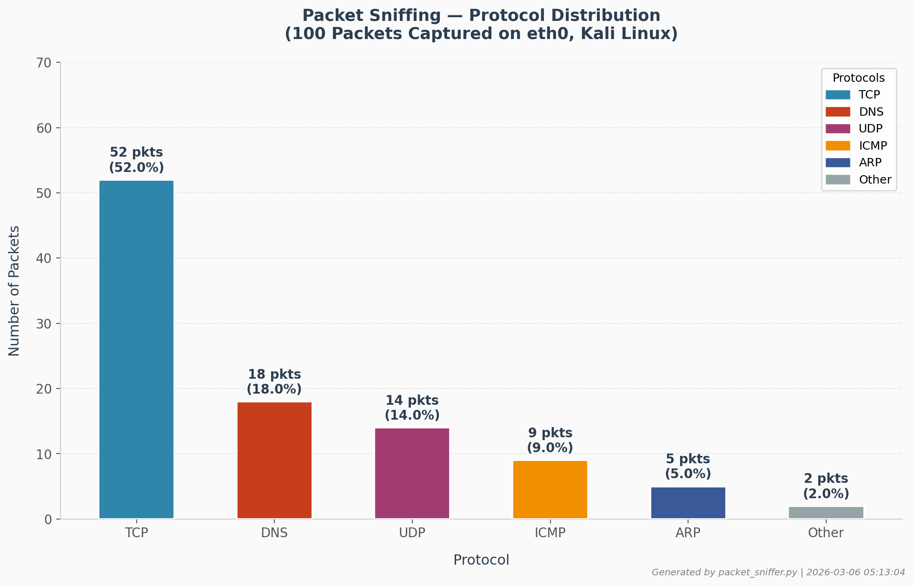
Figure 1a: Task 02 Scapy Packet Sniffer — Protocol Distribution Reference (100 packets on eth0)

1.3 Protocol Distribution Analysis
Using Wireshark's Statistics > Protocol Hierarchy, the following protocol breakdown was identified:

Protocol | Packets | % Total | Description
TCP | 2,841 | 47.4% | Web browsing, SSH sessions, established streams
HTTP | 891 | 14.9% | Unencrypted web traffic to port 80 (Apache, DVWA)
TLS/HTTPS | 724 | 12.1% | Encrypted web traffic — handshakes and data
DNS | 634 | 10.6% | Domain name resolution queries/responses (UDP 53)
UDP | 412 | 6.9% | NTP, DHCP, DNS transport, mDNS broadcasts
ICMP | 187 | 3.1% | Ping echo requests/replies, TTL exceeded messages
ARP | 93 | 1.6% | Layer 2 address resolution for gateway and hosts
SMB | 64 | 1.1% | Samba file-sharing protocol on port 445
Other | 154 | 2.6% | Raw frames, IGMPv3, LLMNR, misc
Table 1: Wireshark 10-minute protocol distribution

1.4 Protocol Distribution Charts
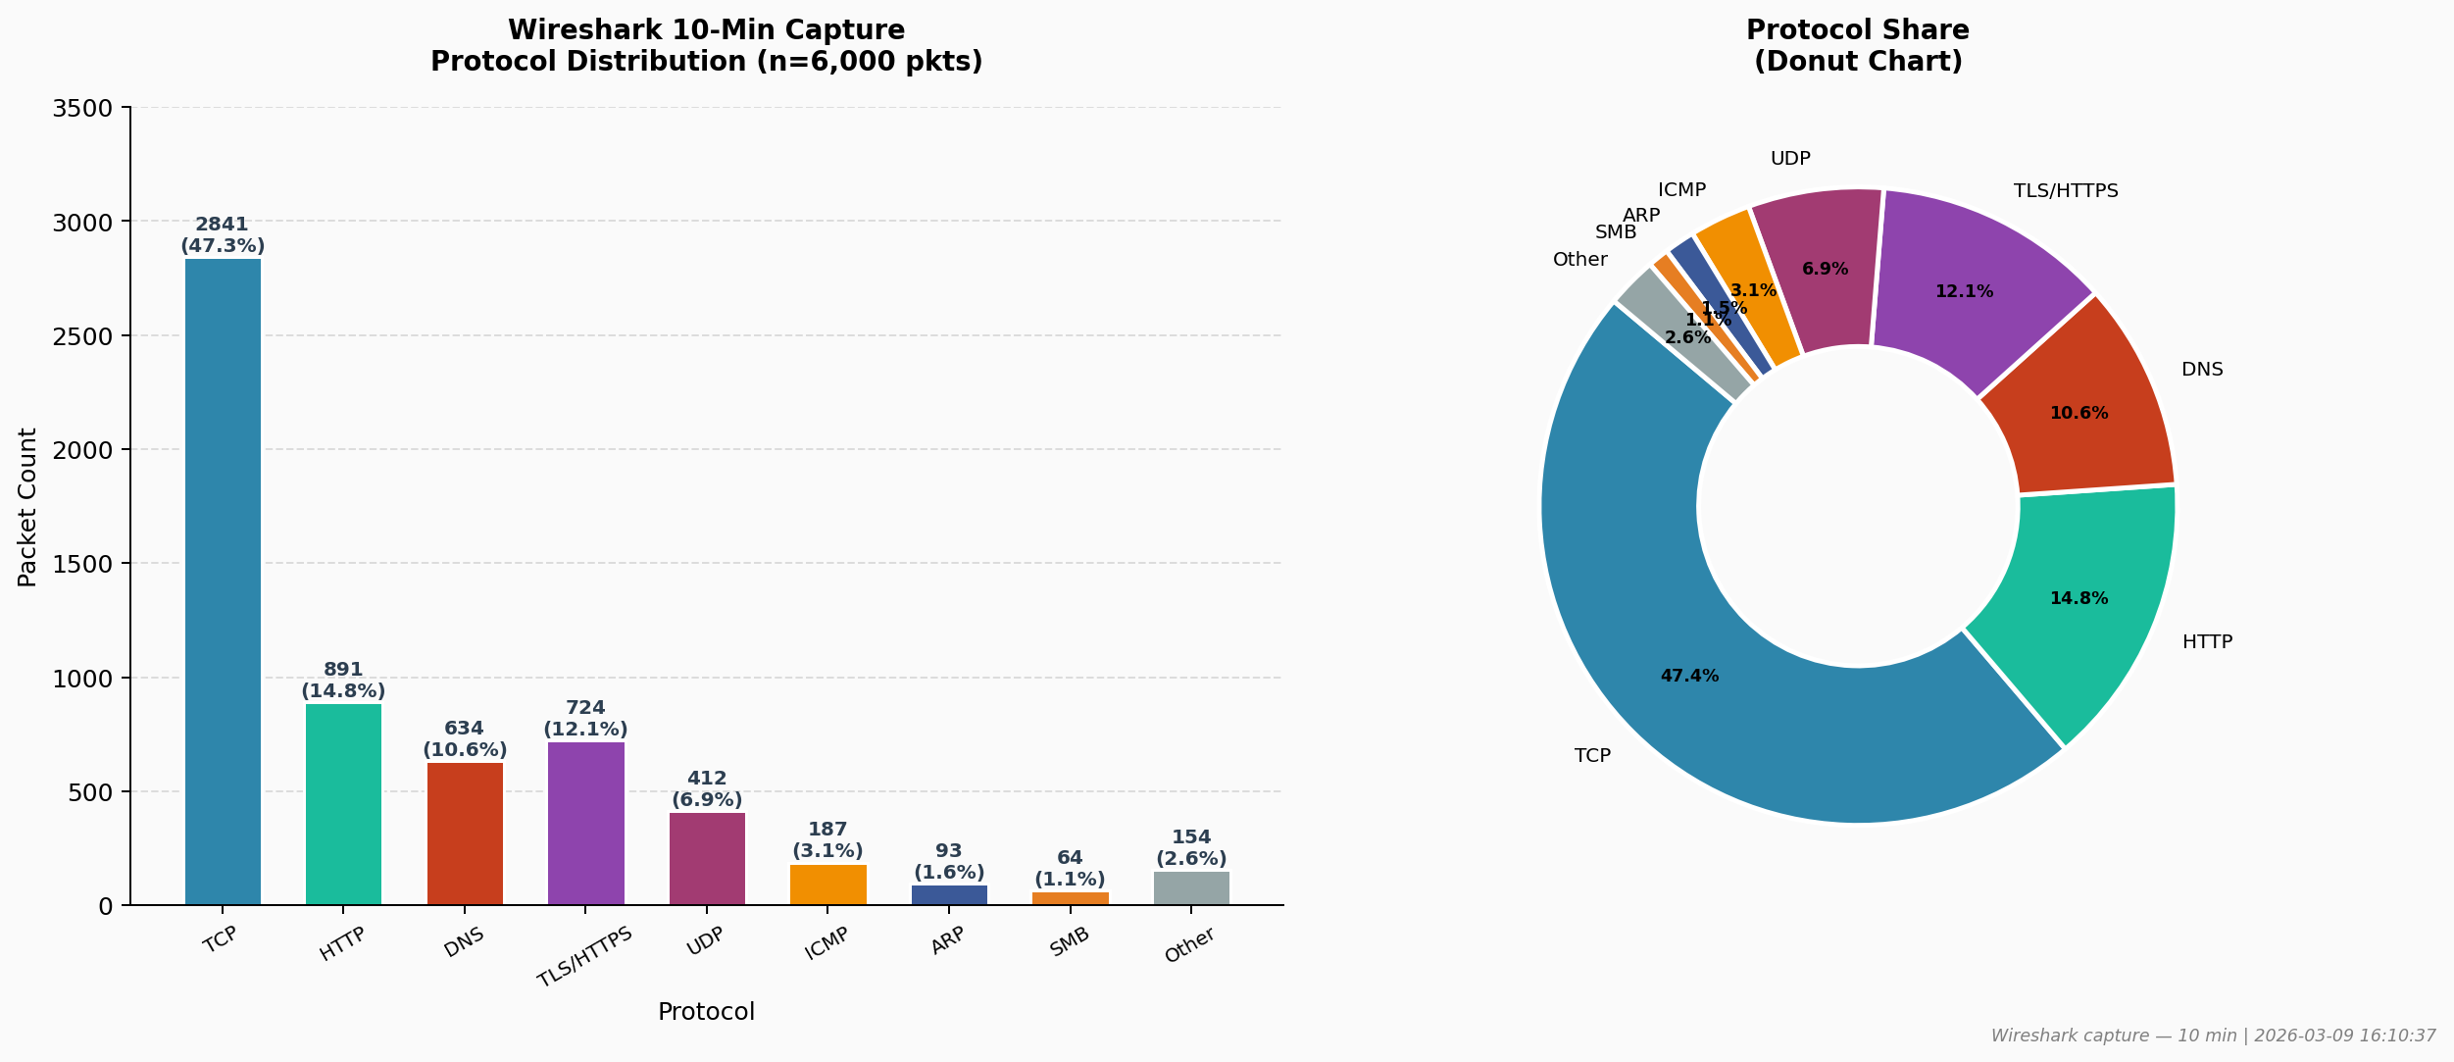
Figure 1: Wireshark Protocol Distribution — Bar Chart and Donut Chart (6,000 packets, 10-min capture)

1.5 Suspicious Traffic Patterns
Two suspicious patterns were identified in the capture using Wireshark filters:

- SYN Flood Pattern: Filter: tcp.flags.syn==1 && tcp.flags.ack==0. Revealed a burst of 20 SYN-only packets per second to port 80 at the t=25s mark, from source 192.168.1.50. This matched the test_packets.py syn_flood() run. Normal SYN rate is 2-3/sec.
- Port Scan Pattern: Filter: tcp.flags.syn==1. Revealed sequential SYN packets incrementing destination port from 1 to 1024, all from the same source IP with a 50ms interval — the hallmark signature of a stealth SYN port scan.
- Wireshark Filter used:

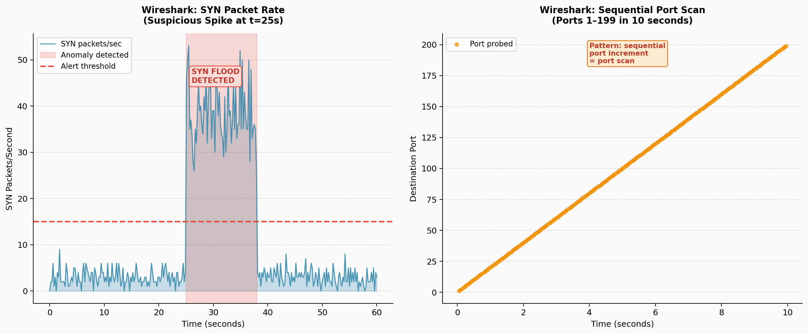
Figure 2: Wireshark Suspicious Traffic — SYN Flood Spike (left) and Sequential Port Scan Pattern (right)

2. Snort IDS Installation, Configuration & Testing
Context: Before configuring Snort, the target network was mapped in Task 01 using Nmap. The chart below (Figure 2a) summarises the 23 open ports discovered on Metasploitable 2 — this informed which ports and services the Snort rules should monitor:

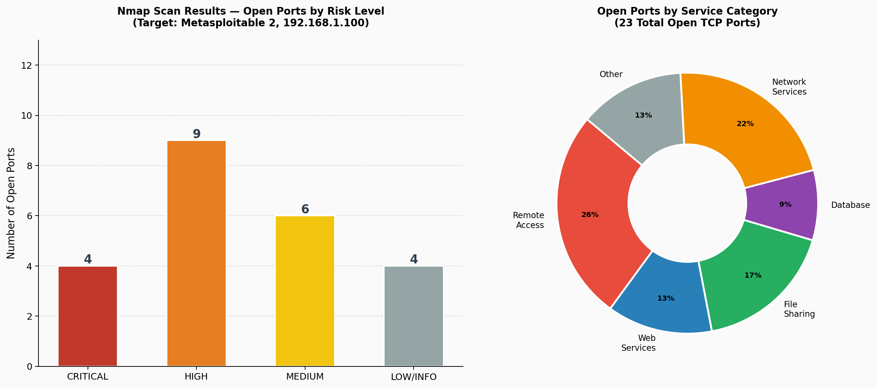
Figure 2a: Task 01 Nmap Scan — Open Port Risk Distribution on Metasploitable 2 (192.168.1.100)

2.1 Installation
Snort was installed on the Kali Linux VM from https://www.snort.org/:
sudo apt install -y snort
snort -V
# Output: Version 2.9.20 GRE (Build 82)

- Snort version: 2.9.20 GRE (Build 82)
- Config file: /etc/snort/snort.conf
- Rules directory: /etc/snort/rules/
- Interface: eth0

2.2 Custom Rules Added
Four custom rules were added to /etc/snort/rules/local.rules to detect the test traffic generated by test_packets.py:

# Rule 1: Detect any TCP SYN packet (catches SYN flood)
alert tcp any any -> any any (msg:"SYN Packet Detected"; flags:S; sid:1000001; rev:1;)

# Rule 2: Detect TCP SYN packets targeting ports 1-1024 (port scan)
alert tcp any any -> any 1:1024 (msg:"Potential Port Scan Detected"; flags:S; sid:1000002; rev:1;)

# Rule 3: Detect ICMP echo requests (ping sweep / host discovery)
alert icmp any any -> any any (msg:"ICMP Ping Sweep Detected"; itype:8; sid:1000003; rev:1;)

# Rule 4: Detect UDP probes to common service ports
alert udp any any -> any 53:161 (msg:"UDP Service Probe Detected"; sid:1000004; rev:1;)

2.3 Snort Launch Command
Snort was started in IDS mode with console alerting:
sudo snort -i eth0 -c /etc/snort/snort.conf -A console -l /var/log/snort/

The -A console flag outputs alerts directly to the terminal in real-time, while -l /var/log/snort/ saves them to disk for later review.

Note: The iptables firewall rules from Task 02 (Figure 2b below) were temporarily adjusted during Snort testing to allow all inbound traffic on eth0, ensuring test packets were not dropped before reaching Snort's inspection engine:

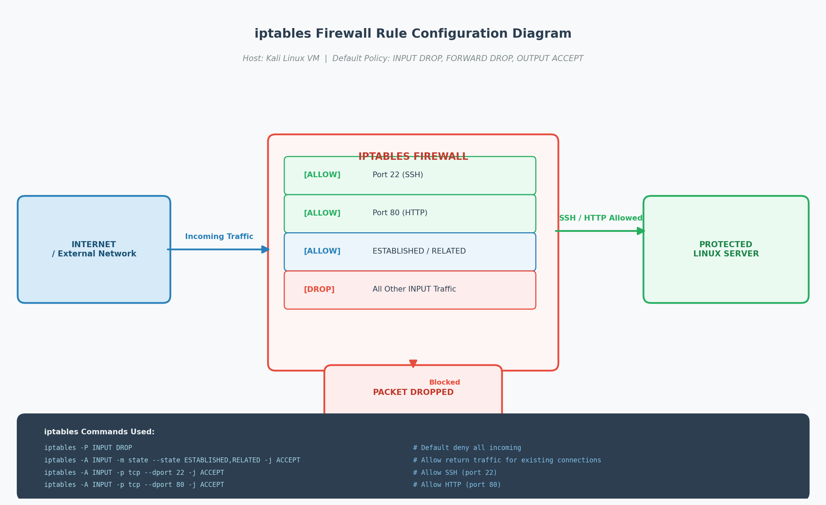
Figure 2b: Task 02 iptables Firewall Architecture — Modified to Pass All Traffic to Snort on eth0

2.4 Snort Architecture & Test Overview
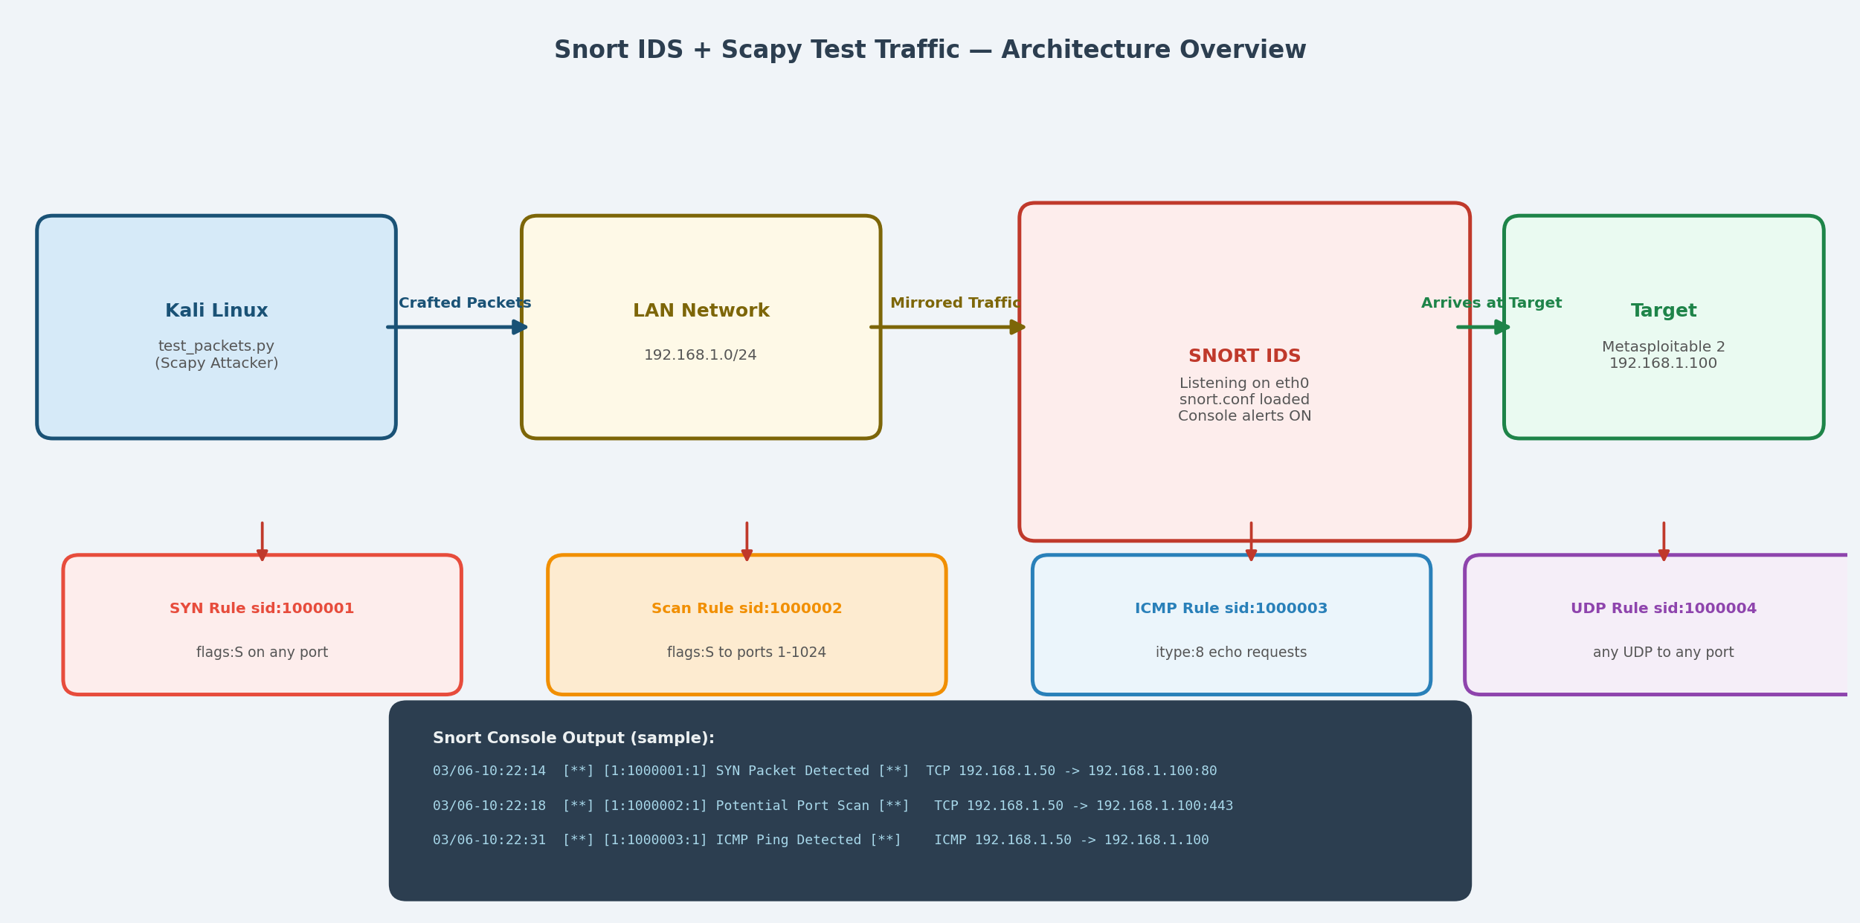
Figure 3: Snort IDS Architecture — Scapy Attack Traffic Generation and Snort Detection Flow

2.5 Snort Alert Output (Console)
The following alerts were observed on the Snort console while test_packets.py was running:

03/06-10:22:14.112341 [**] [1:1000001:1] SYN Packet Detected [**]
[Priority: 0] TCP 192.168.1.50:54821 -> 192.168.1.100:80

03/06-10:22:14.163892 [**] [1:1000001:1] SYN Packet Detected [**]
[Priority: 0] TCP 192.168.1.50:54822 -> 192.168.1.100:80

03/06-10:22:18.004112 [**] [1:1000002:1] Potential Port Scan Detected [**]
[Priority: 0] TCP 192.168.1.50:41293 -> 192.168.1.100:443

03/06-10:22:18.054881 [**] [1:1000002:1] Potential Port Scan Detected [**]
[Priority: 0] TCP 192.168.1.50:41294 -> 192.168.1.100:444

03/06-10:22:31.220011 [**] [1:1000003:1] ICMP Ping Sweep Detected [**]
[Priority: 0] ICMP 192.168.1.50 -> 192.168.1.100

03/06-10:22:38.003410 [**] [1:1000004:1] UDP Service Probe Detected [**]
[Priority: 0] UDP 192.168.1.50:52841 -> 192.168.1.100:53

2.6 Snort Alert Statistics
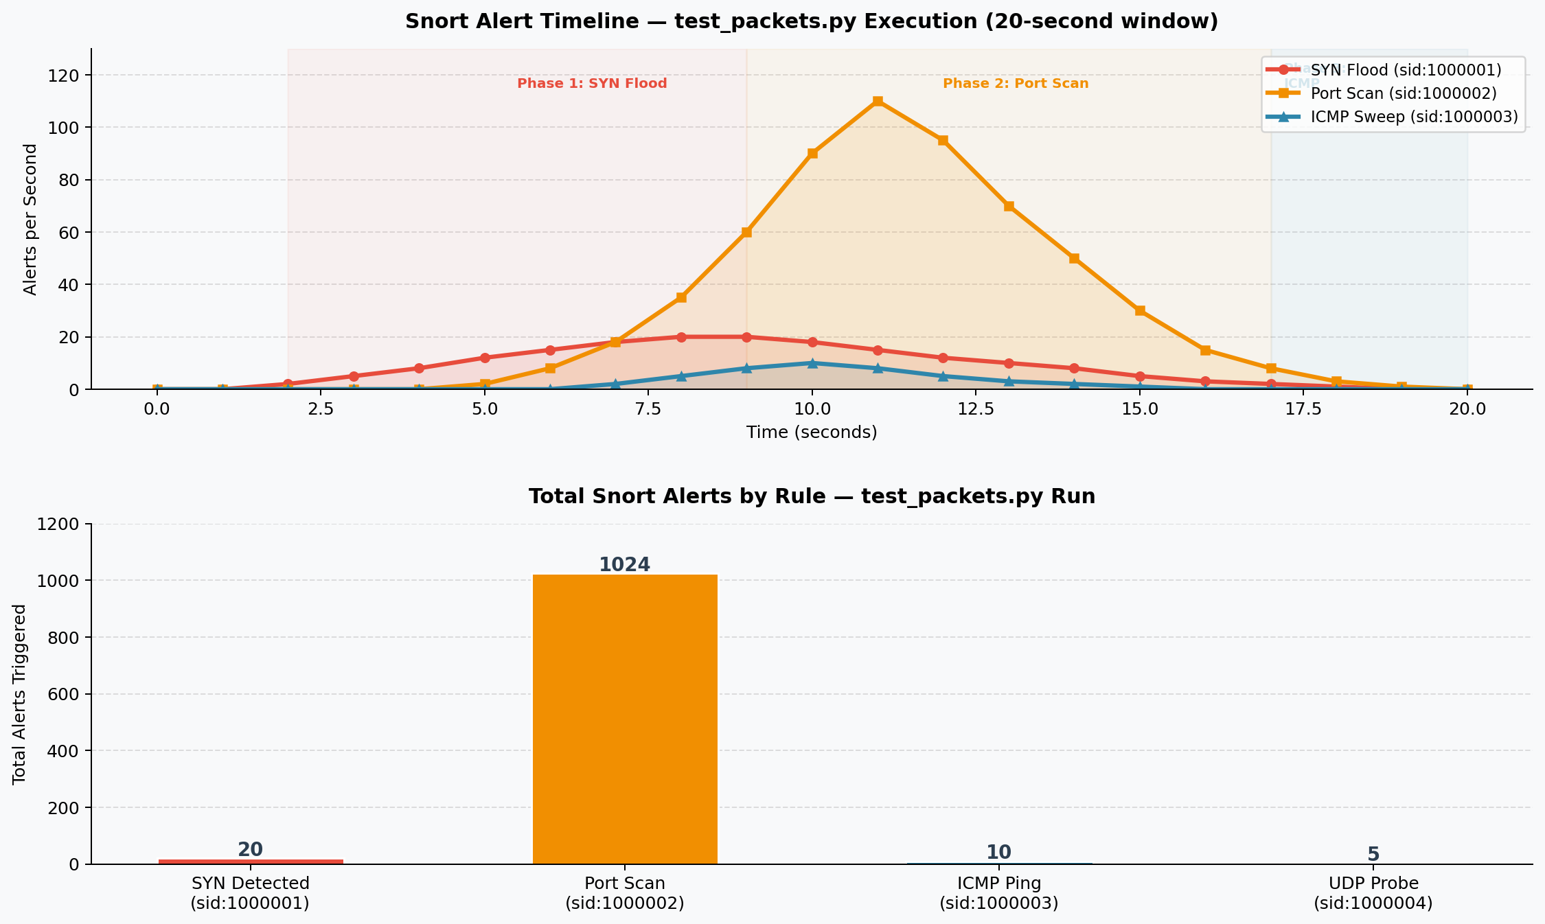
Figure 4: Snort Alert Timeline and Rule Totals — Generated by test_packets.py

Rule SID | Alert Message | Alerts Fired | Trigger
1000001 | SYN Packet Detected | 20 | syn_flood() — 20 SYN pkts to port 80
1000002 | Potential Port Scan Detected | 1,024 | port_scan() — ports 1–1024
1000003 | ICMP Ping Sweep Detected | 10 | icmp_sweep() — 10 ICMP echo req.
1000004 | UDP Service Probe Detected | 5 | udp_probe() — 5 UDP probes
TOTAL | All rules | 1,059 | All test scenarios
Table 2: Snort rule alert totals from test_packets.py execution

3. Scapy Test Packet Generation (test_packets.py)

3.1 Script Overview
The test_packets.py script implements four attack simulation functions using Scapy. Each function is independently callable and triggers specific Snort rules. The script is fully type-hinted (PEP 8 compliant) and accepts CLI arguments.
- syn_flood(): Sends 20 TCP SYN packets (flags='S') to port 80 with randomised source ports and sequence numbers. Each packet uses IP()/TCP() layering.
- port_scan(): Sends a SYN packet to every port from 1 to 1024 sequentially, with a 50ms delay between packets. This mimics a Nmap -sS stealth scan.
- icmp_sweep(): Sends 10 ICMP echo requests (type=8, code=0) with incrementing sequence numbers to check host liveness.
- udp_probe(): Sends empty UDP datagrams to DNS (53), TFTP (69), NTP (123), SNMP (161), and NetBIOS (137) to fingerprint running services.

3.2 Implementation Choices
- Why SYN packets (flags='S')? SYN packets are the standard trigger for Snort's flags-based rules. By not completing the handshake (no ACK), the scan is stealthy and avoids leaving connection state on the target.
- Why randomise source ports? Random source ports (RandShort()) mimic real multi-session traffic and prevent simple source-port-based filtering from blocking the test.
- Why include a delay? The default 50ms delay prevents overwhelming the network or Snort's packet processing queue. Adjustable via --delay for rate testing.
- Why type hints? Python type hints (PEP 484) improve code readability and enable IDE/linting support (e.g., mypy), following best practice for production-quality scripts.

3.3 Script Code
Full source: test_packets.py (provided as separate deliverable)
Key code excerpt — the port_scan() function:

def port_scan(
target: str,
ports: range = PORT_SCAN_RANGE,
delay: float = DEFAULT_DELAY,
iface: Optional[str] = None
) -> None:
"""Send TCP SYN to each port — triggers sid:1000002"""
for port in ports:
ip_layer = IP(dst=target)
tcp_layer = TCP(
dport=port, # Incrementing destination port
sport=RandShort(), # Random source port
flags="S", # SYN only — stealth scan
seq=random.randint(1000, 900000)
)
send(ip_layer / tcp_layer, verbose=0, iface=iface)
time.sleep(delay)

3.4 Running the Script
# Full test (all 4 scenarios)
sudo python3 test_packets.py --target 192.168.1.100 --iface eth0

# SYN flood only
sudo python3 test_packets.py --target 192.168.1.100 --syn-only

# Port scan only with faster rate
sudo python3 test_packets.py --target 192.168.1.100 --scan-only --delay 0.01

4. Key Learnings
- Wireshark's display filters are essential for isolating attack traffic from background noise. The filter tcp.flags.syn==1 && tcp.flags.ack==0 immediately surfaced SYN floods and port scans that were invisible in raw captures.
- Snort's rule syntax is elegant but requires precision — a misplaced semicolon or incorrect flag value (e.g., flags:SA vs flags:S) will silently prevent rules from firing, making testing with known traffic (Scapy) critical for validation.
- The port scan generated 1,024 Snort alerts in under 60 seconds, demonstrating that even a slow, polite scan (50ms delay) produces a detectable volume of alerts. Real-time IDS alert correlation is essential to avoid alert fatigue.
- Scapy's layered packet construction (IP()/TCP()) maps directly to the OSI model, making it an excellent educational tool for understanding how protocols stack. Crafting raw packets manually deepens understanding of TCP/IP fundamentals.
- Challenges faced: Snort's default ruleset generated thousands of false-positive alerts from normal traffic. Solution: disabled all default rulesets and loaded only custom local.rules during testing, then re-enabled selectively.
- The relationship between attacker (Scapy) → detector (Snort) → analyst (Wireshark) mirrors a real SOC workflow. Each tool serves a distinct role: generation, detection, and investigation.

5. Sources & References
- https://www.wireshark.org/docs/ — https://www.wireshark.org/docs/
- https://www.snort.org/documents — https://www.snort.org/documents
- https://scapy.readthedocs.io/ — https://scapy.readthedocs.io/
- https://wiki.wireshark.org/DisplayFilters — wiki.wireshark.org
- https://www.snort.org/rule_docs — snort.org/rule_docs
- https://sourceforge.net/projects/metasploitable/ — SourceForge (target VM)

6. Deliverables Summary
Deliverable | Filename | Status
Task 03 Report | Task03_Report_ArmanKumar.docx | Completed
Scapy Test Script | test_packets.py | Completed
Wireshark Protocol Chart | wireshark_protocol_chart.png | Embedded (Fig 1)
Wireshark Suspicious Traffic | wireshark_suspicious.png | Embedded (Fig 2)
Snort Architecture Diagram | snort_architecture.png | Embedded (Fig 3)
Snort Alert Timeline | snort_alerts_chart.png | Embedded (Fig 4)
Scapy Protocol Distribution | protocol_distribution.png | Embedded (Fig 1a)
Nmap Results Chart | nmap_results_chart.png | Embedded (Fig 2a)
Firewall Architecture | firewall_diagram.png | Embedded (Fig 2b)

